Life History Traits and Genetic Diversity:

The Effects on He in Marine Species

Marial Malabag

Rutgers University

Introduction

Genetic diversity is vital as it can lead to new types of creatures or simply allow for adaptations. By adapting to unique circumstances thanks to beneficial mutations, some species can ensure their survival. There are different ways to categorize such survival tactics that can lead to diversity, such as R and K strategists. Focusing on genetic variety in species, from people to seahorses, allows a better understanding of the genome as a whole and brings to light possible environmental conditions that can cause an increase or decrease in genetic diversity.

Why is it essential to study genetic variation in species? There are several reasons why, ranging from being more informed to economic effects related to genetic diversity. It allows researchers to have a better understanding of the genomic library of species, ranging from mammals to marine species. Seeing how mutations can lead to beneficial adaptations allows for more discoveries and possible innovations. It enables researchers to characterize the natural selection history of species and the genetic relationships (Luo et al. 2019). The study of genetic diversity is also essential from an economic standpoint. Studying the variations in species may allow others to pinpoint what specific aspects correlate with the increase or decreasing diversity in a species. Knowing the relationship is especially necessary if the studies in question focus on essential elements to human life, researching species that people rely on as either food or economic sources. By studying different species, we can learn if important species with higher genetic diversity can result in a possible decrease of competition for resources, ultimately causing a higher survival rate and (McLeod & Marshall 2009). By devoting attention to these animals, scientists can see whether the species require conservation efforts to protect animals and, ultimately, the human lifestyle (Rosenberg & Kang 2015; Lynch 2016).

Finding out the causes to genetic diversity gives us a better understanding of the environment and the relationships that govern adaptations and change. There have been many theories which influence the genome to have higher genetic diversity. However, the main conclusions have been tied to population size.  There have been studies conducted that also seem to support that claim that a large population size leads to higher diversity, and vice versa (Harrang et al. 2013). This may be because of the chances. By having a larger number of offspring, the chances of having higher variation also increase. Another study also concludes that possible higher diversity is due to the faster reproduction times and high rates of gene flow of species’s higher population (Hague & Routman 2015). There may also be other factors that don’t rely heavily on the idea of higher population leading to more diversity. For example, a species may have more diversity because it is more prone to have more mutations in the genome, not necessarily due to higher populations. A study focused on this topic, concluding that with mtDNA markers was studied has more variation independently from a specie’s population. It was also acknowledged that life history traits may not have a specific relationship with mitochondrial markers, causing the study’s conclusion (Nabholz, Glemin, & Galtier 2009). Body size was used as a proxy to account for varying population sizes, leading to a negative correlation. The introduction of body size as another big player in the topic of genetic diversity, especially in relation to population size, brings to mind the theory of R- and K-strategists in species.

R & K strategists focus on the relationship between population size and productivity. R strategists rely on the model of having a large number of offspring but a shorter lifespan. They try to allocate more resources and their energy to reproduce as much as they can. These kinds of strategists tend to be much smaller as well, making sense when it comes to their expected longevity. These smaller species tend to have much more offspring because of possible mortality rates due to predation or harsh environments (Winemiller & Rose 1993).  K strategists focus more on "competitive ability." These types of strategists tend to have a longer lifespan and larger body size but have very few offspring. By having aspects that allow the species to survive longer (like larger body length), they can spread out the time and energy along their entire lifetime when it comes to caring for offspring, unlike R-strategists that dedicate all that energy in a very short amount of time period (Adams 1980). All these aspects, the categorization of species as either R- or K- strategists must be kept in mind going forward.

Multiple research topics have focused on R- & K- strategists and the relationship with high genetic diversity. One study concluded, that R-strategists seem to have higher genetic variation compared to K-strategists, due in part because species of higher populations can withstand the risk that is needed to be such a strategist (Romiguier et al. 2014). However, it should also be understood that genetic diversity is not the end-all, be-all of understanding survival. Higher genetic variation does not necessarily mean absolute survival. An example is the eventual extinction of the Galapagos finches, and how, despite the high genetic diversity, the environment changed too rapidly for their genes to compensate (University of Cincinnati 2019). Therefore, mutations may just be less common, eventually leading to lower genetic diversity in species overall. However, the biggest problem with the previous studies mentioned, though, is the use of different markers to obtain information. There seem to be differences in results when it comes to comparing nucleotide diversity and microsatellite heterozygosity. Although there are still positive correlations with population and genetic diversity, the variation differs significantly from nucleotide diversity and microsatellites which alters final results (Väli et al. 2008). Another study also concluded that there could be many reasons that mitochondrial DNA data may not work. In the study focusing on arthropods, there are microorganisms that can be passed down. Some were beneficial but the parasitic organisms specifically target the mitochondria. The micro-organisms change the original mitochondrial DNA haploid to one linked to the parasite. This change passes down to future offspring, homogenizing the DNA and future generations as a whole. The linkage disequilibrium in turn makes the genetic diversity data collected lower than it might actually be (Hurst 2005). These factors must be acknowledged during the analysis and data collection. According to another previous study, fecundity may not affect genetic diversity when focusing specifically on mitochondrial DNA data (Bazin, Glémin, & Galtier, 2006). It is important to keep in mind that mitochondrial DNA data will not always line up with microsatellite data and other outside factors may actually affect the final result as a whole. Microsatellites also have problems with the idea of neutrality and selection. Despite being favored due to its neutrality, there still can be selection “due to its action on linked loci,” resulting in background selection and selective sweeps that ultimately affect the microsatellites and genetic variation (Vali et al. 2008). Ultimately, in order to have the best results would need to incorporate both markers to account for the shortcomings of the other.

Despite there being many research projects dedicated to filling in the gaps for the unknown aspects of genetic diversity, it encompasses such an extensive range of factors. There are still many aspects that have not been figured out. For example, we don't know how often genetic variation plays a role in favoring beneficial mutations and the genome (Cutter & Payseur 2013). What specific life history trait or combination of characteristics is the most significant contributor to genetic diversity?

As stated previously, genetic diversity, especially in marine species, could be the result of various factors. From latitude/longitude to body length to reproduction strategies could cause either large or small genetic diversity in thousands of species. Despite the multitude of factors that could affect an outcome, the four traits that I want to focus on are body length, fertilization, reproduction mode, and fecundity of the species.

I am predicting that as body length increases, genetic diversity decreases. In a previous study, although they focused more on the relationship between catch and diversity, they also claimed and found that there seems to be a negative relationship between the two (McCusker & Betzen, 2010). There can be many reasons why smaller body size can have higher genetic diversity. For example, a study concluded that smaller species have higher variation due to its rate of molecule evolution (Doyle 2015). This conclusion can tie with the previous study, both of which are not unwarranted as this is a studied concept that was mentioned before, R- and K- strategies. Since smaller body length usually correlates with higher fecundity, associated with R-strategists, it can be theorized that there will be higher genetic diversity.

The next life trait focused on was fertilization. I predict that the external fertilization method would yield higher genetic diversity. External fertilization may yield higher genetic diversity based on the fact that there can be multiple males. My belief is that by having many offspring fertilized by multiple males, there can be higher genetic diversity. This results in higher genetic diversity since there is one female that has her eggs fertilized by multiple males, there can be offspring that have different genetic makeup purely by the fact that the fathers vary between the progeny. Having a large population that was fertilized by many males can increase genetic diversity. In smaller populations, there may be lower diversity, creating a bottleneck. It’s harder to see the significance resulting in diversity from internal fertilization species, but one can assume that the genetic diversity in external fertilization species would be higher.

Fecundity is another life trait that also is known to be a factor of R- and K- strategists mentioned before. Like body length, fecundity seems to have an effect on reproduction, which in turn affects genetic diversity. However, unlike body length, fecundity is believed to have a positive relationship with expected heterozygosity. I believe that the more offspring an individual has, the more likely there will be higher genetic diversity just due to probability. This assumption is tied with the idea of R- and K-strategists, as smaller body length results in higher fecundity. There have been multiple studies that support this notation. In one study, focusing on the genetic diversity differences between marine and freshwater species, marine species seem to have a higher genetic diversity due to the larger population sizes (Martinez, Willoughby, & Christie 2018). Overall, because of the studied relationship between fecundity and genetic diversity, the conclusion that larger populations can result in more genetic variation.

The last life history trait I want to focus on is the reproduction modes of marine species. I predict that hermaphroditic species (protogyny, protandry, or true hermaphroditism) would also have offspring with higher genetic diversity. The belief is that, by being hermaphroditic, the chances of reproduction can increase. There is no limitation on the sex of the fish that is around. For example, if the present circumstances require a female fish, then the fish can change into a female and allow for fertilization by present male fish. By adapting to the conditions, the individuals and species as a whole have more opportunities to reproduce. The need for adaptation is present in clownfish. If the female dies, a male will change and take over as the female. These environmental factors, as well as genetics, allow for more offspring, leading to higher genetic diversity (Kobayashi et al. 2018). The question of sex ratios related to hermaphroditic species have been posed before. Although it isn’t extremely well-known, the idea of sex change relating to skewed sex ratios have been studied. As a dioecious species, there is no luxury to switch sex in order to balance the sex ratio. Hermaphrodites have this opportunity, switching sex in order to balance the sex ratios of the population. It also has been suggested that skewed sex ratios may decrease population size which has been mentioned previously to possible increasing genetic diversity (Rosche 2018). Variation in reproduction modes can account for and balance out these skewed ratios, allowing there to be more offspring that can have higher genetic diversity (Smith 1994). There are other reasons that cause the evolution of hermaphroditic species that would eventually contribute to higher genetic diversity. From the idea of skewed sex ratios forcing a sex change in an individual to the *size advantage model* that possess more efficient reproduction as one specific sex at the beginning of one’s life and switching to later in life for more efficient reproduction as another sex to just adaptations (Leonard 2006, Ghiseling 1969). This also allows to have more offspring in general, tying in with the idea that larger population size leads to higher genetic diversity, mentioned previously.

In summary, my main focus of the project was to focus on the individual relationships of body length, fertilization, fecundity, & reproduction mode vs. expected heterozygosity.

Methods & Data Collection

I received select data of marine fish species for both microsatellites and mitochondrial DNA collections. The data collection process was uniform among the hundreds of papers analyzed. There was about 20 columns of data collected. For the sake of this research, the data entered that was used during or important for this research project was the following: scientific name, common name, source, country, latitude & longitude (degrees, minutes and seconds if stated), collection year, number of markers used, marker names, if the markers were cross-species, sample size, expected heterozygosity, and standard error of expected heterozygosity. Using this information, I wrote a R script that pulled data from Fishbase. I pulled data for the several life history traits. However, the data that I focused on for the rest of my analysis were as stated before: body length, fertilization, fecundity, and reproduction mode. Some data had to be manipulated due to what information was recorded. One example is for max length. Some species had specific data, that being the length of the female individual. This was accounted for in the code. A similar problem was also seen for fecundity. There was different data collected for fecundity, either being fecundity max, min or mean. When pulling the data from Fishbase, fecundity mean was pulled first, followed by fecundity min and then fecundity max if the first two weren’t available. In the final analysis, fecundity mean was taken as it gave the best value for a range of fecundity as well as being the easiest to obtain.  All information was pulled for both microsatellites and mitochondrial DNA separately.

After receiving the full data csv’s for marine species, both with microsatellite and mitochondrial DNA data, I went and merged my mitochondrial DNA data with the full mitochondrial DNA dataset together, repeating this process with microsatellites. From there, I focused on four specific traits: fertilization, reproduction mode, max length, and fecundity mean. I wrote a R script that analyzed the data against He (genetic diversity), plotting them in the respective plots. For fertilization, reproduction mode box plots were required. I also created another box plot that separates reproduction mode even further. The first reproduction mode box plot was split between dioecious species and hermaphrodites. The second plot split the hermaphrodites up, resulting in four categories: dioecious, protandry, protogyny, & true hermaphroditism. For max length (with and without the Rhincodon Typus species) and fecundity mean, scatter plots were required. I also created density plots for max length (w/ Rhincodon Typus) and fecundity mean. I performed two-way anova tests for fertilization method, reproduction mode, and specific reproduction modes as well as Wilcoxon tests for max length (w/ Rhincodon Typus) and fecundity mean. Rather than using a linear regression model, I performed a generalized linear model, plotting the binomial regression lines on the scatter plots. This gives a better understanding of the relationship between the individual trait and expected heterozygosity. Because the mtDNA data was analyzed separately from msat data, at the end of my script, I compared all the plots previously created together, combining them so it is easier to understand. An important note to keep in mind is that there is much more microsatellite data than mitochondrial DNA data which may influence results and conclusions.

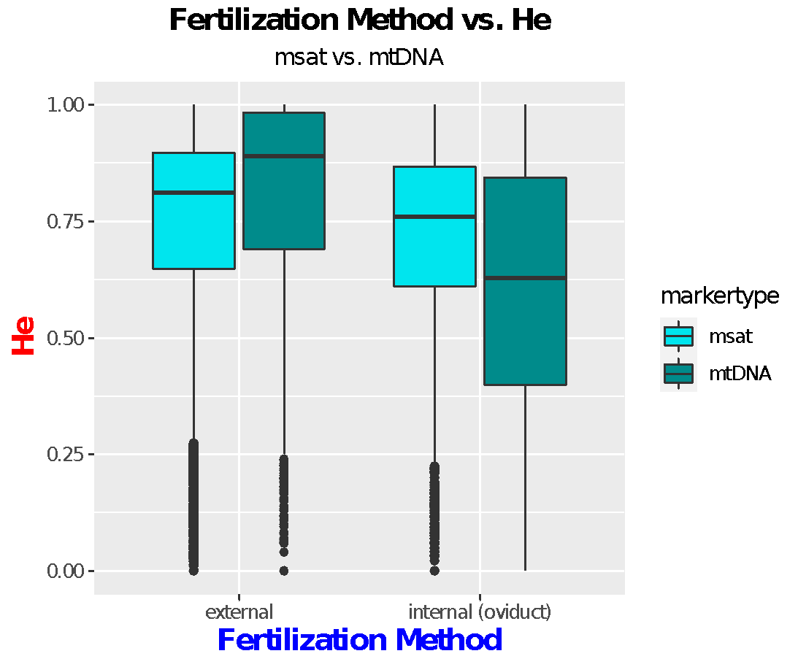Results:

Running the R scripts allowed me to collect the data I was looking for. The first graph I obtained was a boxplot showing the relationship between fertilization methods and He. The plot seems to support my hypothesis that external fertilization leads to more genetic diversity. It is more noticeable with the mtDNA data as the mean for external fertilization is much higher than internal fertilization. For the microsatellite data, the means look much closer. However, external fertilization still seems to yield more genetic variation than internal fertilization. To be sure, I performed an two-way anova tests which showed there to be significance when it comes to fertilization methods, allowing me to reject the null hypothesis and conclude that there is a significant relationship between fertilization method and He (p values for: fertilization = 2e-16, marker type = .00135, fertilization:markertype = 2e-16; See more in supplementary materials).

For reproduction modes vs. He, I decided to create two separate graphs. The first graph would just focus on dioecious vs. hermaphroditic species. The plot supports the hypothesis that hermaphroditic species have genetic diversity than dioecious species. Again, it is more apparent with the mtDNA data, as the hermaphrodite mean is much higher. The means for microsatellite 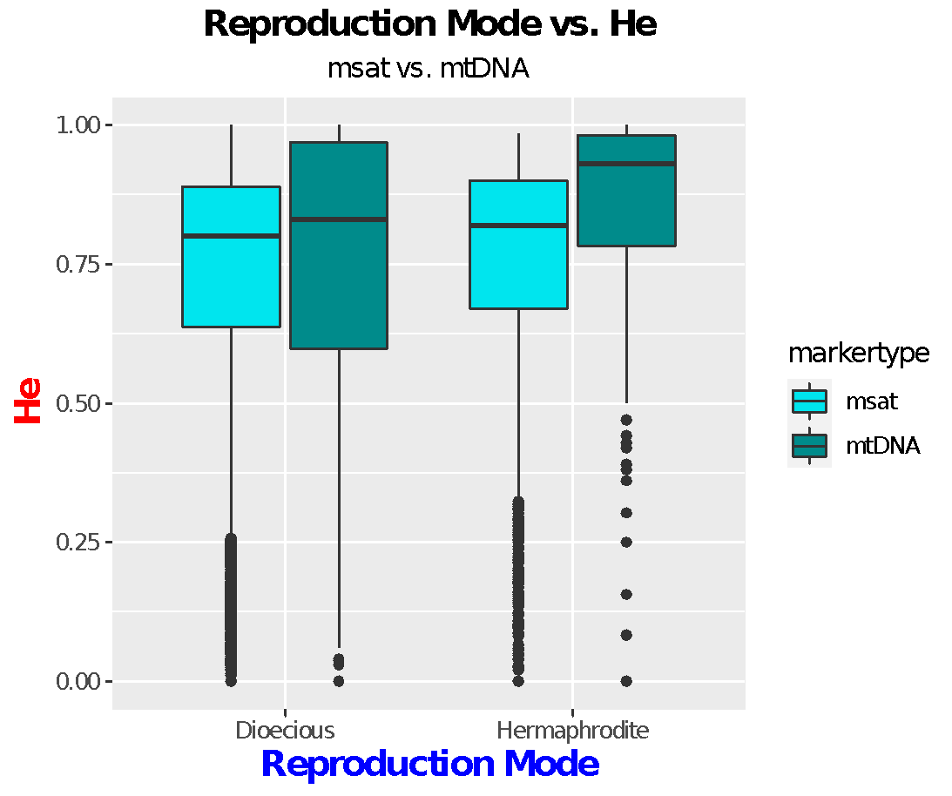data is closer but hermaphrodites have a slightly higher mean. The second graph created separated hermaphrodites into the separate categories so it is easier to see the specific means for each type (protandry, protogyny, & true Hermaphroditism). The three different types of reproduction for hermaphrodites all have means that are larger than dioecious species. For microsatellite data, protandry and protogyny reproduction have relatively similar means with protandry resulting in a large He. This relationship varies from mtDNA data, which display protogyny reproduction with a higher He. It is important to note that for both markers, true hermaphroditism has the highest mean. This may because fewer species are true hermaphrodites, 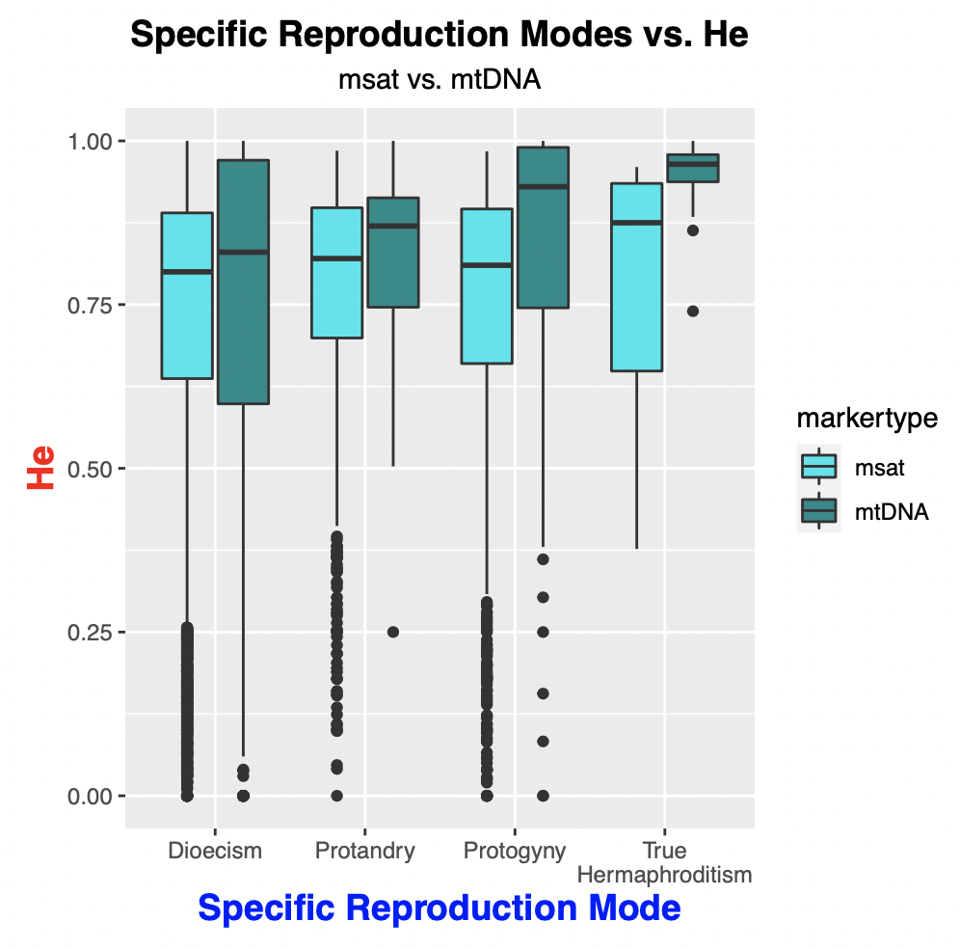resulting in a smaller sample size that results in a majority high He. To confirm the results and conclusion, I performed an two-way anova test for both graphs/datasets. In addition to the two-way anova test, I also performed a Tukey range test on the specific reproduction mode. For just the Reproduction Mode vs. He, the p values showed a high level of significance, allowing me to come to the conclusion that reproduction mode and expected heterozygosity have a relationship and allows me to reject the null hypothesis (p values for: reproduction mode = 7.53e-15, marker type = 0.00109, reproductionmode:markertype = 2.95e-10; See more in supplementary materials). For the second graph/dataset relating to specific reproduction mode, the Tukey range test had to be taken to see the specific p values of every different relationship. Overall, almost every relationship was significant apart from protogyny-protandry for both marker types (p value = 0.302477; See more detailed information for every relationship in Supplementary materials).

Next, I focused on max length which required a scatter plot. I had created two separate plots, one with Rhincodon Typus and one without for clarity. As expected, there was a negative correlation between length and expected heterozygosity. There seems to be a sharper decrease in 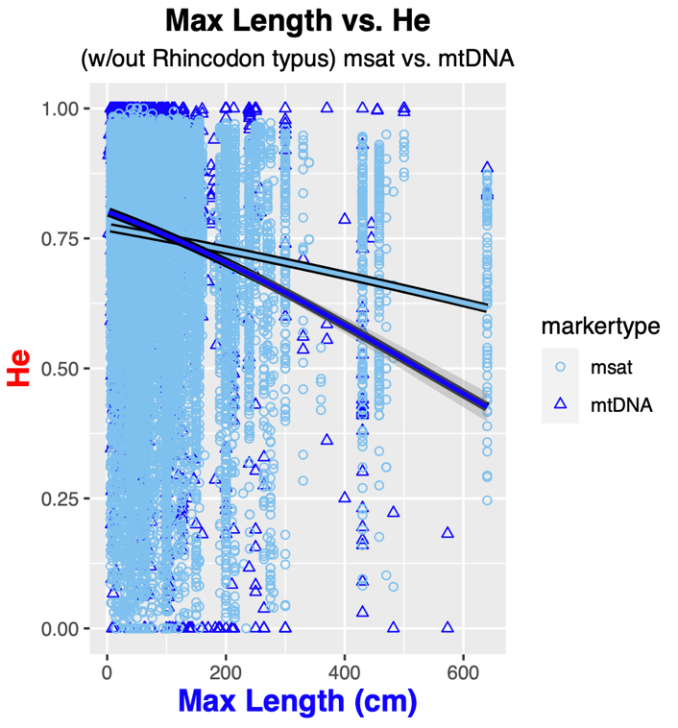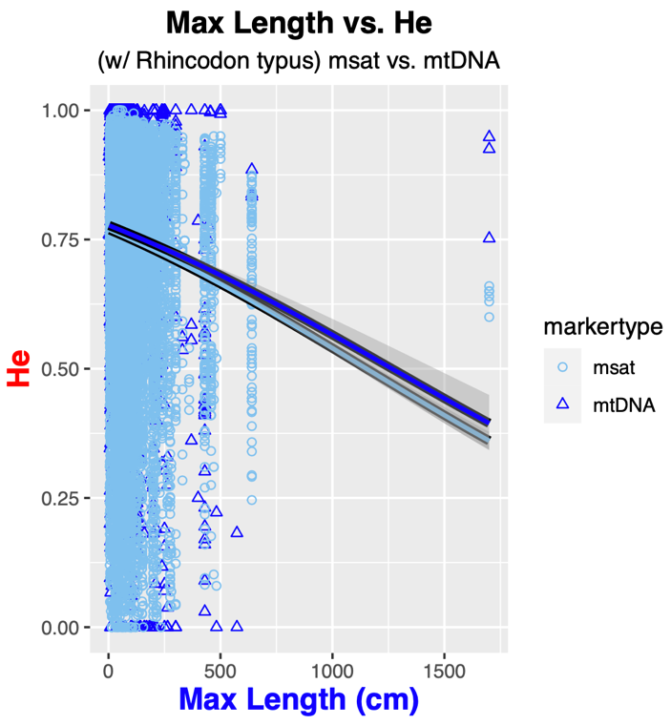the mitochondrial DNA data than the microsatellite data. Another thing to point out is that the microsatellite data seems to have no change in binomial regression when the Rhincodon Typus data was removed. However, the mtDNA data changed, albeit by 0.01, when the Rhincodon 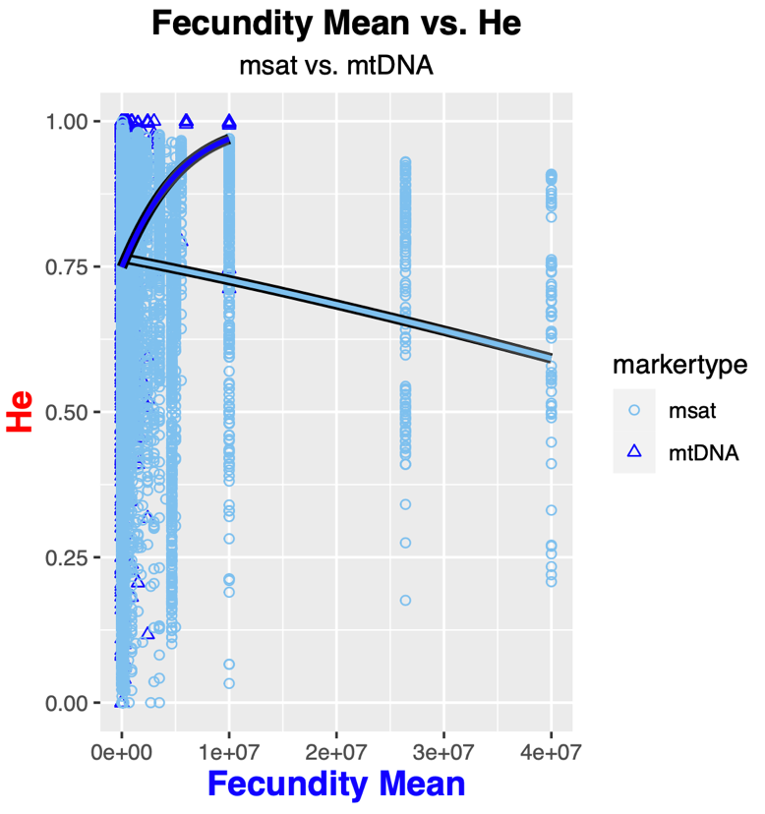Typus data was removed.

The last plot created illustrated the relationship between mean fecundity and He. It is important to note that out of all the data used for the previous plots, fecundity mean has the smallest recorded amount of data, which may or may not affect the final results. For the mtDNA marker, the scatter plot supports the hypothesis that a higher fecundity may lead to higher genetic diversity. Because mtDNA has less data, there seems to be a steeper increase in slope as opposed to the microsatellite data.

Discussion

Overall, the majority of the data collected aligned with my hypothesis. External fertilization methods yielded a higher genetic diversity. Despite the marker types having different ranges of means for external & internal fertilization, the p value shows that the results are still significant. This may mean that the claim of possibly having multiple males fertilize one batch of eggs can increase genetic variation can be true. The idea that hermaphroditic species also have a higher genetic diversity seems to be supported by the results. When just looking simply at the anova relating dioecious species vs. hermaphroditic species, there is reason to believe that there is an actual relationship between reproduction mode and He. When even examining the information closer, nearly every aspect is significant. The reason for the relationship between protandry-protogyny being the only one to not have a significant p value might be in part due to them being very nearly similar. The only difference between the two is that protandry means a change from male to female while protogyny means a change from female to male. Therefore, it makes sense how there isn’t a significant difference between the two due to their closeness in the sex change process. True hermaphroditism’s relationship with both are significant just because it isn’t as similar; the marine species possess both male and female reproductive organs at the same time. The second half of my analysis focusing on the numerical data offered some surprises. As expected, max length (both with and without the Rhincodon typus points included) showed a negative relationship with expected heterozygosity. However, the surprise was the relationship with fecundity vs. He.

I expected there to be a positive relationship between fecundity and expected heterozygosity. Instead, the mitochondrial DNA illustrated a positive correlation while the microsatellite data showed a negative correlation. There could be multiple reasons to explain this deviation from my hypothesis. With regards to the dramatic difference in relationships between microsatellite and mitochondrial DNA, this could be because of the amount of data collected. Unlike the other life history traits, fecundity had the smallest amount of data collected. The microsatellite dataset also contained more studies than mtDNA. Because of this, the mtDNA data set had the smallest sample size with regards to fecundity, skewing the results. If there was more information, it may have also caused a negative correlation for mtDNA as well. It is also wholly possible that there could be a positive correlation for both markers if there was more data collected. The result of having mtDNA show a positive correlation was also quite surprising because if there were to be a parasite or something similar that altered the mitochondria of the species, it would ultimately cause lower genetic diversity in not only the individual but the following offspring. This aspect should be noted and have further research focused on this idea in the future. In general, the first aspect of the differing results could be a result of smaller sample size with regards to which studies recorded fecundity. The second aspect could be purely because of survival. My belief was that a larger number of offspring could mean there’s a higher chance of high genetic diversity. This was supported with my mtDNA data as stated before. Along those lines with the assumption that the mtDNA data was skewed due to smaller sample size, we can also postulate that something similar happened to the microsatellite data. The microsatellite data had more information than the mtDNA data set, but maybe not nearly enough. There is a wider range of He results compared to the mtDNA data set, possibly causing this negative relationship for microsatellite data. As for a possible explanation that doesn’t include the amount of data collected, it could be that higher fecundity just ultimately leads to lower genetic diversity with specific species. Perhaps certain species just have a smaller chance of having higher genetic diversity or there are outliers that may just result in a lower genetic diversity despite higher fecundity. Overall, the fecundity results have been surprising and would maybe be improved upon by collecting more data.

Another aspect to consider with all the factors studied is how they relate. It is possible that results are tied together rather than being the only thing that influence expected heterozygosity. For example, fertilization and reproduction mode should be considered together. Both aspects influence the other, one such being, but not limited to, external fertilization tying in with protandrous species like seen in Acanthopagrus australis. Therefore, it shouldn’t be seen as fertilization being the sole cause of higher genetic diversity or vice versa, it is possible that it is a combination of different traits as well that leads to higher genetic diversity. Same should be said with body length and fecundity, especially since they are already related with the idea of R- and K- strategists. There might not be one sole factor that causes the variation. Another factor to keep in mind is cause and effect. My hypothesis focused mostly on different life history traits and the tie in with the idea of R- and K- strategists, rather than the individual trait. Therefore, there are limitations with the project. Maybe one trait causes the other or maybe one trait is the result of another instead. It’s difficult to pinpoint without the proper, specific studies. Maybe in the future, there can be specific studies that focus on just the specific traits and how exactly they are tied together. By being able to clearly see the distinctions between the relationships between the life history aspects, it may be easier to see and understand the results of expected heterozygosity.

The project allows to see the relationship between expected heterozygosity vs the four life history traits: body length, fecundity, fertilization, & reproduction mode. Although the conclusions had followed more or less with my hypothesis, it is always important to know that there could be future improvement. As stated before, it’s important to study and know the clear distinctions and relationships between multiple traits. There may also be other aspects that could be changed, for example taking Pi instead of He for the mitochondrial DNA, or improved upon, like getting more data for both markers. However, the results obtained are important in their own right. It allows us to see what may contribute to higher genetic diversity in marine species, giving us the opportunity to understand the species. It gives us more information that can also be used in the future. Genetic diversity in marine species is vital to understand the way of life in our very own oceans. In the future, the results now, and hopefully studied more later on, can result in beneficial actions taken to protect the species. It may also allow us to further education and understanding of how genetic diversity is as a whole in marine life.

References:

Adams, P.B. (1980) Life history patterns in marine fishes and their consequences for fisheries management. Fishery Bulletin 78, 1–12.

Asher D. Cutter, & Bret A. Payseur. (2013). Genomic signatures of selection at linked sites: unifying the disparity among species. *Nature Reviews Genetics*, *14*(4), 262–274. https://doi.org/10.1038/nrg3425

Coates, D., Byrne, M., & Moritz, C. (2018). Genetic Diversity and Conservation Units: Dealing With the Species-Population Continuum in the Age of Genomics. *Frontiers In Ecology And Evolution*, *6*. https://doi.org/10.3389/fevo.2018.00165

Bazin, E., Glémin, S., & Galtier, N. (2006). Population Size Does Not Influence Mitochondrial Genetic Diversity in Animals. Science, 312(5773), 570–572. <https://doi.org/10.1126/science.1122033>

Ghiselin, M. (1969). The Evolution of Hermaphroditism Among Animals. The Quarterly Review of Biology, 44(2), 189–208. <https://doi.org/10.1086/406066>

Hague, M., & Routman, E. (2015). Does population size affect genetic diversity? A test with sympatric lizard species. Heredity, 116(1), 92–98. https://doi.org/10.1038/hdy.2015.76

Harrang, E., Lapègue, S., Morga, B., Bierne, N., & Harrang, E. (2013). A high load of non-neutral amino-acid polymorphisms explains high protein diversity despite moderate effective population size in a marine bivalve with sweepstakes reproduction. G3 (Bethesda, Md.), 3(2), 333–341. <https://doi.org/10.1534/g3.112.005181>

Hurst, G., & Jiggins, F. (2005). Problems with mitochondrial DNA as a marker in population, phylogeographic and phylogenetic studies: the effects of inherited symbionts. Proceedings Of The Royal Society B-Biological Sciences, 272(1572), 1525–1534. <https://doi.org/10.1098/rspb.2005.3056>

Jacqueline M. Doyle, Claire C. Hacking, Janna R. Willoughby, Mekala Sundaram, & J. Andrew DeWoody. (2015). Mammalian Genetic Diversity as a Function of Habitat, Body Size, Trophic Class, and Conservation Status. Journal of Mammalogy, 96(3), 564–572. https://doi.org/10.1093/jmammal/gyv061

Kobayashi Y., Nozu R., Horiguchi R., Nakamura M. (2018) Variety of Sex Change in Tropical Fish. In: Kobayashi K., Kitano T., Iwao Y., Kondo M. (eds) Reproductive and Developmental Strategies. Diversity and Commonality in Animals. Springer, Tokyo

Leonard, J. (2006). Sexual selection: lessons from hermaphrodite mating systems. Integrative and Comparative Biology, 46(4), 349–367. <https://doi.org/10.1093/icb/icj041>

Luo, Z., Brock, J., Dyer, J., Kutchan, T., Schachtman, D., Augustin, M., Ge, Y., Fahlgren, N., & Abdel-Haleem, H. (2019). Genetic Diversity and Population Structure of a Spring Panel. *Frontiers in Plant Science*, *10*, 184. https://doi.org/10.3389/fpls.2019.00184

Lynch, A. (2016, April 26). Why is Genetic Diversity Important? Retrieved July 16, 2020, from https://www.usgs.gov/center-news/why-genetic-diversity-important

Martinez, A. S., Willoughby, J. R., & Christie, M. R. (2018). Genetic diversity in fishes is influenced by habitat type and life-history variation. Ecology and evolution, 8(23), 12022–12031. https://doi.org/10.1002/ece3.4661

Mccusker, M., & Bentzen, P. (2010). Positive relationships between genetic diversity and abundance in fishes. Molecular Ecology, 19(22), 4852–4862. <https://doi.org/10.1111/j.1365-294X.2010.04822.x>

McLeod L, Marshall DJ (2009) Do Genetic Diversity Effects Drive the Benefits Associated with Multiple Mating? A Test in a Marine Invertebrate. PLOS ONE 4(8): e6347. <https://doi.org/10.1371/journal.pone.0006347>

Nabholz, B., Glémin, S., & Galtier, N. (2009). The erratic mitochondrial clock: variations of mutation rate, not population size, affect mtDNA diversity across birds and mammals. BMC Evolutionary Biology, 9(1), 54–54. https://doi.org/10.1186/1471-2148-9-54

Romiguier, J., Gayral, P., Ballenghien, M., Bernard, A., Cahais, V., Chenuil, A., Chiari, Y., Dernat, R., Duret, L., Faivre, N., Loire, E., Lourenco, J., Nabholz, B., Roux, C., Tsagkogeorga, G., Weber, A., Weinert, L., Belkhir, K., Bierne, N., … Galtier, N. (2014). Comparative population genomics in animals uncovers the determinants of genetic diversity. Nature (London), 515(7526), 261–263. https://doi.org/10.1038/nature13685

Rosenberg, N. A., & Kang, J. T. (2015). Genetic Diversity and Societally Important Disparities. *Genetics*, *201*(1), 1–12. <https://doi.org/10.1534/genetics.115.176750>

Smith, P. (n.d.). Genetic diversity of marine fisheries resources : possible impacts of fishing . Food and Agriculture Organization of the United Nations.

University of Cincinnati. (2019, August 22). Genetic diversity couldn't save Darwin's finches: Extinct populations of Galapagos finches had higher genetic diversity than many survivors. *ScienceDaily*. Retrieved July 15, 2020 from [www.sciencedaily.com/releases/2019/08/190822124840.htm](http://www.sciencedaily.com/releases/2019/08/190822124840.htm)

Väli, Ü., Einarsson, A., Waits, L., & Ellegren, H. (2008). To what extent do microsatellite markers reflect genome‐wide genetic diversity in natural populations? Molecular Ecology, 17(17), 3808–3817. <https://doi.org/10.1111/j.1365-294X.2008.03876.x>

Winemiller, K., & Rose, K. (1993). Why Do Most Fish Produce so Many Tiny Offspring? The American Naturalist, 142(4), 585–603. <https://doi.org/10.1086/285559>

Supplementary Materials:

Two-Way Anova Test Results:

Combined Fertilization Anova:

                               Df Sum Sq Mean Sq F value  Pr(>F)

final_fertilization            1 8.3   8.327  190.41 < 2e-16 ***

markertype                     1 0.4   0.449   10.27 0.00135 **

final_fertilization:markertype 1 8.7   8.749  200.06 < 2e-16 ***

Residuals                  22511  984.5   0.044

---

Signif. codes:  0 ‘***’‚0.001 ‘**’‚ 0.01 ‘*’, 0.05 ‘.

~~~~~~~~~~~~~~~~~~~~~~~~~~~~~~~~~~~~~~~~~~~~~~~~~~~~~~~~~~~~~~~~~~~~~~~~~~

Combined Reproduction Mode Anova:

                              Df Sum Sq Mean Sq F value   Pr(>F)

final_reproductionmode         1 2.7  2.6820   60.54 7.53e-15 ***

markertype                     1 0.5  0.4727   10.67  0.00109 **

final_reproductionmode:markertype  1 1.8  1.7607   39.74 2.95e-10 ***

Residuals                     22574 1000.1  0.0443

---

Signif. codes:  0 ‘***’‚0.001 ‘**’‚ 0.01 ‘*’, 0.05 ‘.

~~~~~~~~~~~~~~~~~~~~~~~~~~~~~~~~~~~~~~~~~~~~~~~~~~~~~~~~~~~~~~~~~~~~~~~~~~

Combined Specific Reproduction Mode Anova:

                               Df Sum Sq Mean Sq F value   Pr(>F)

specific.repro_mode            3 4.1  1.3510  30.527  < 2e-16 ***

markertype                     1 0.4  0.4243   9.589  0.00196 **

specific.repro_mode:markertype 3    1.8  0.5877  13.281 1.17e-08 ***

Residuals                  22570  998.8  0.0443

---

Signif. codes:  0 ‘***’‚0.001 ‘**’‚ 0.01 ‘*’, 0.05 ‘.’ 0.1 ‘1’

Combined Specific Reproduction Mode Anova (TukeyHSD summary):

                               Df Sum Sq Mean Sq F value   Pr(>F)

specific.repro_mode            3 4.1  1.3510  30.527  < 2e-16 ***

markertype                     1 0.4  0.4243   9.589  0.00196 **

specific.repro_mode:markertype 3    1.8  0.5877  13.281 1.17e-08 ***

Residuals                  22570  998.8  0.0443

---

Signif. codes:  0 ‘***’‚0.001 ‘**’‚ 0.01 ‘*’, 0.05 ‘.’ 0.1 ‘1’

